**Scripting Task**

**Task Description:**

1. Create a shell script to print the HTTP error code of guvi.in & print, the success/failure message based on the error code response.

Step 1: Create the file

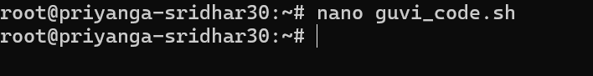

Step 2:Creating a script that fetches the HTTP status code from guvi.in and prints a success or failure message based on the response.

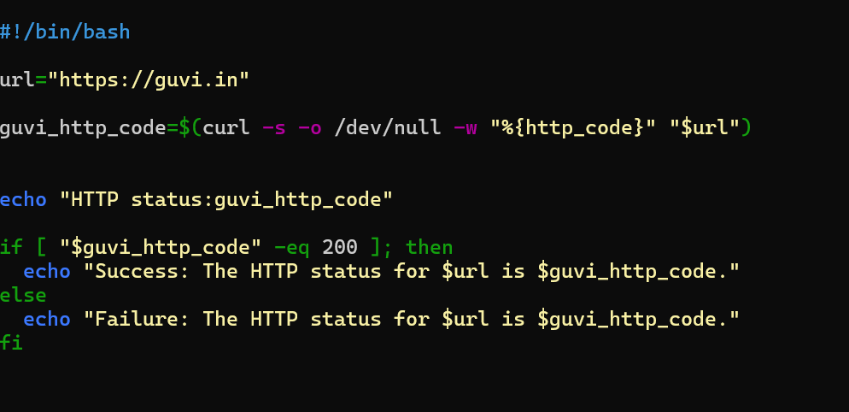

* Step 3: it prints a **failure message** with the code.

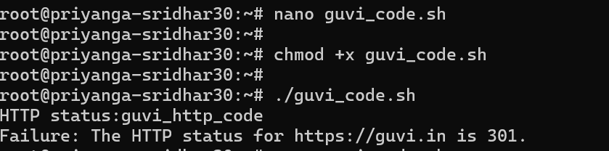

2.Given a file, replace all occurrence of the word "give" with "learning" from 5th line till the end in only those lines that contain the word "welcome".

